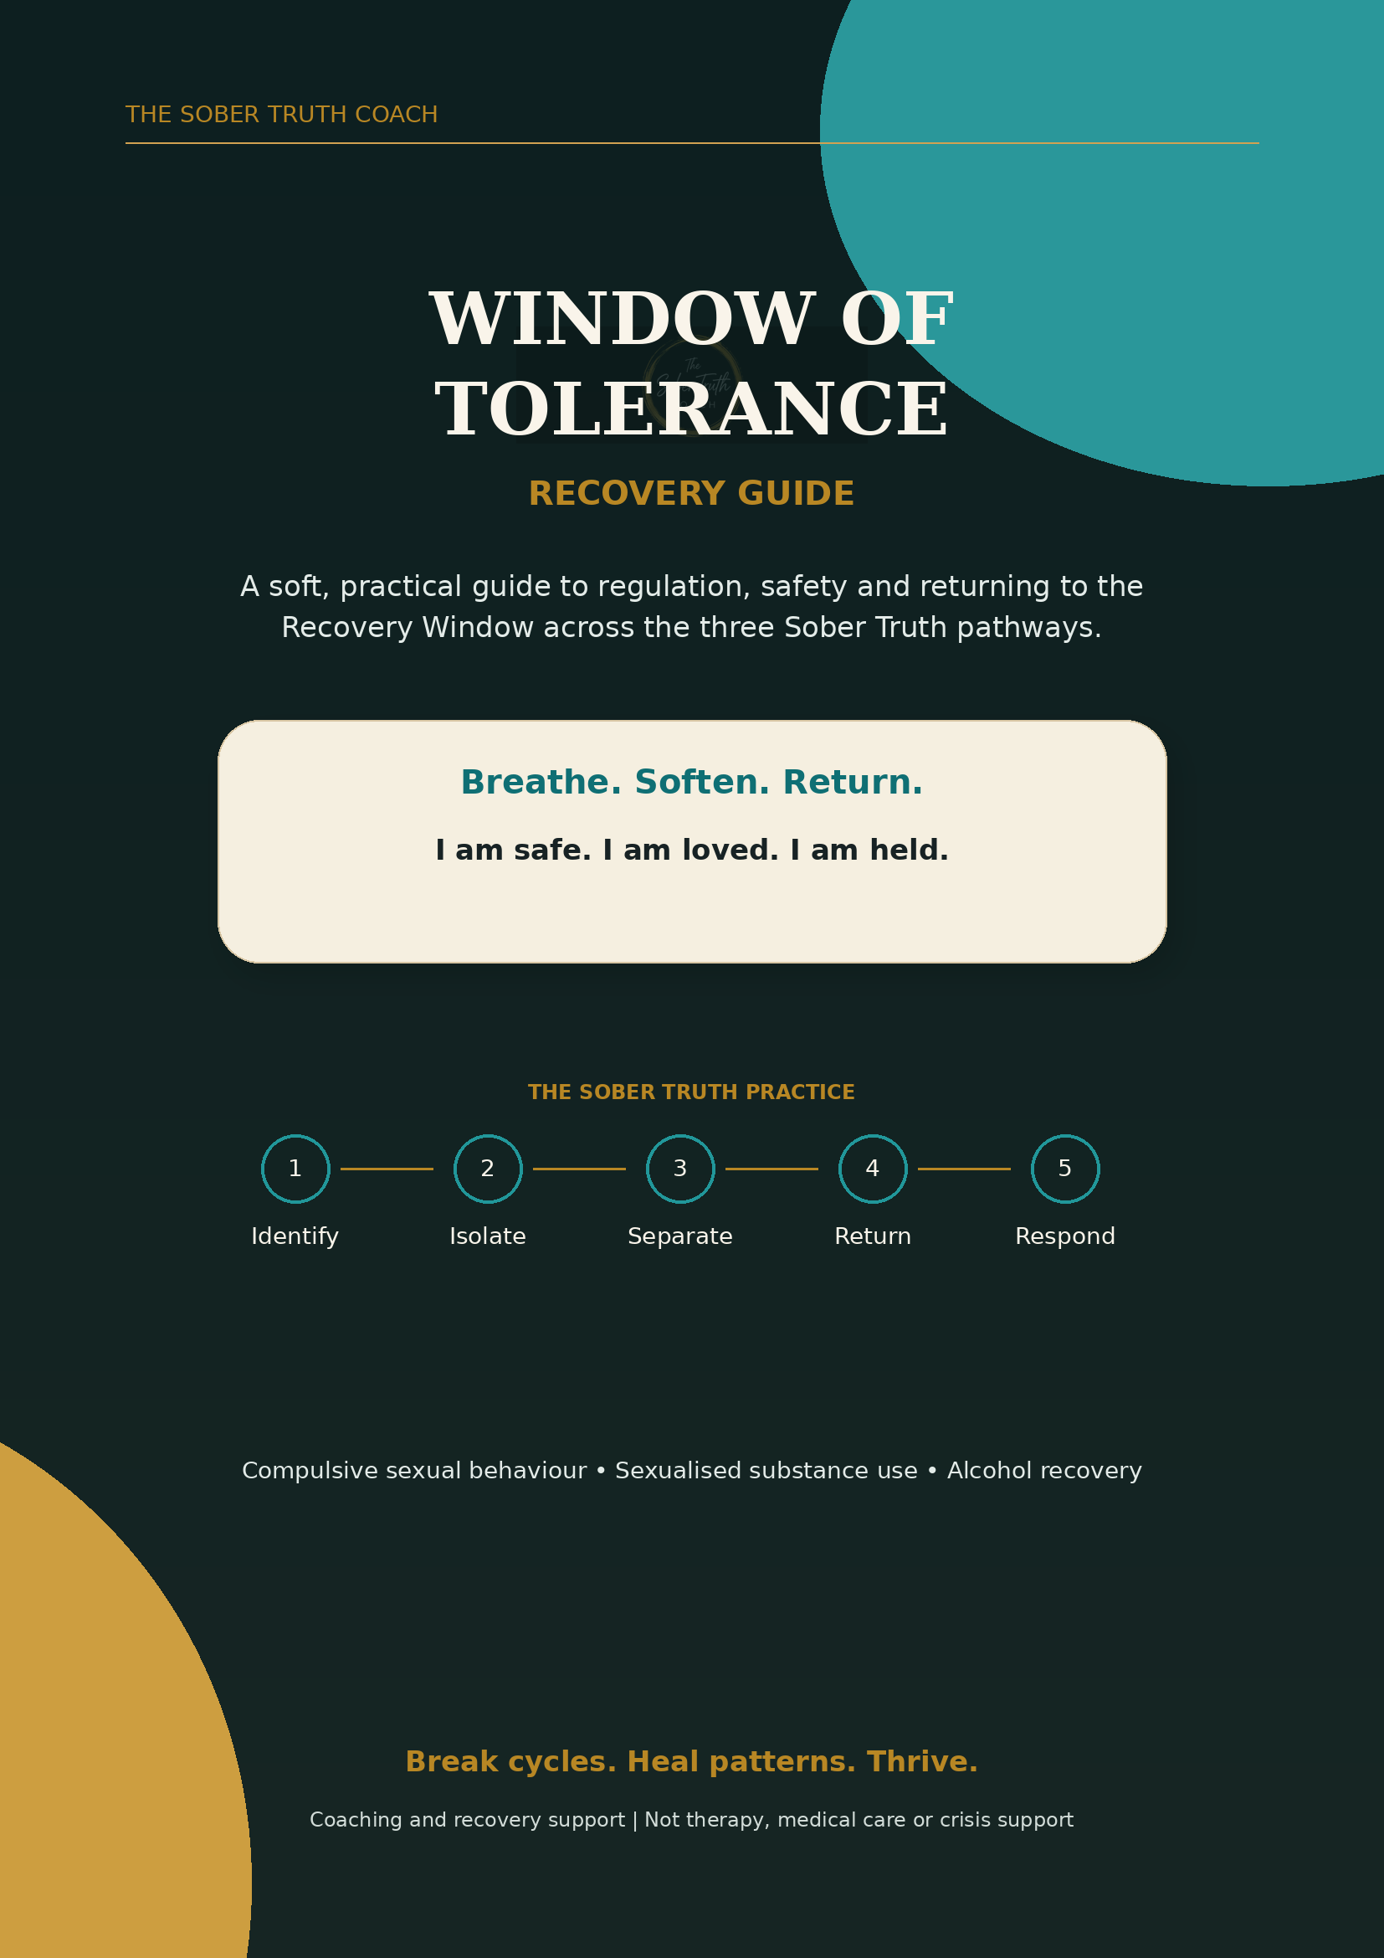

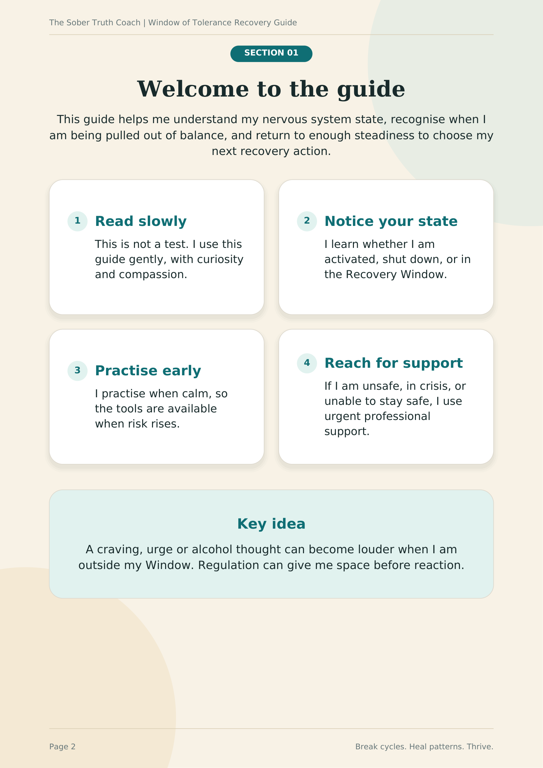

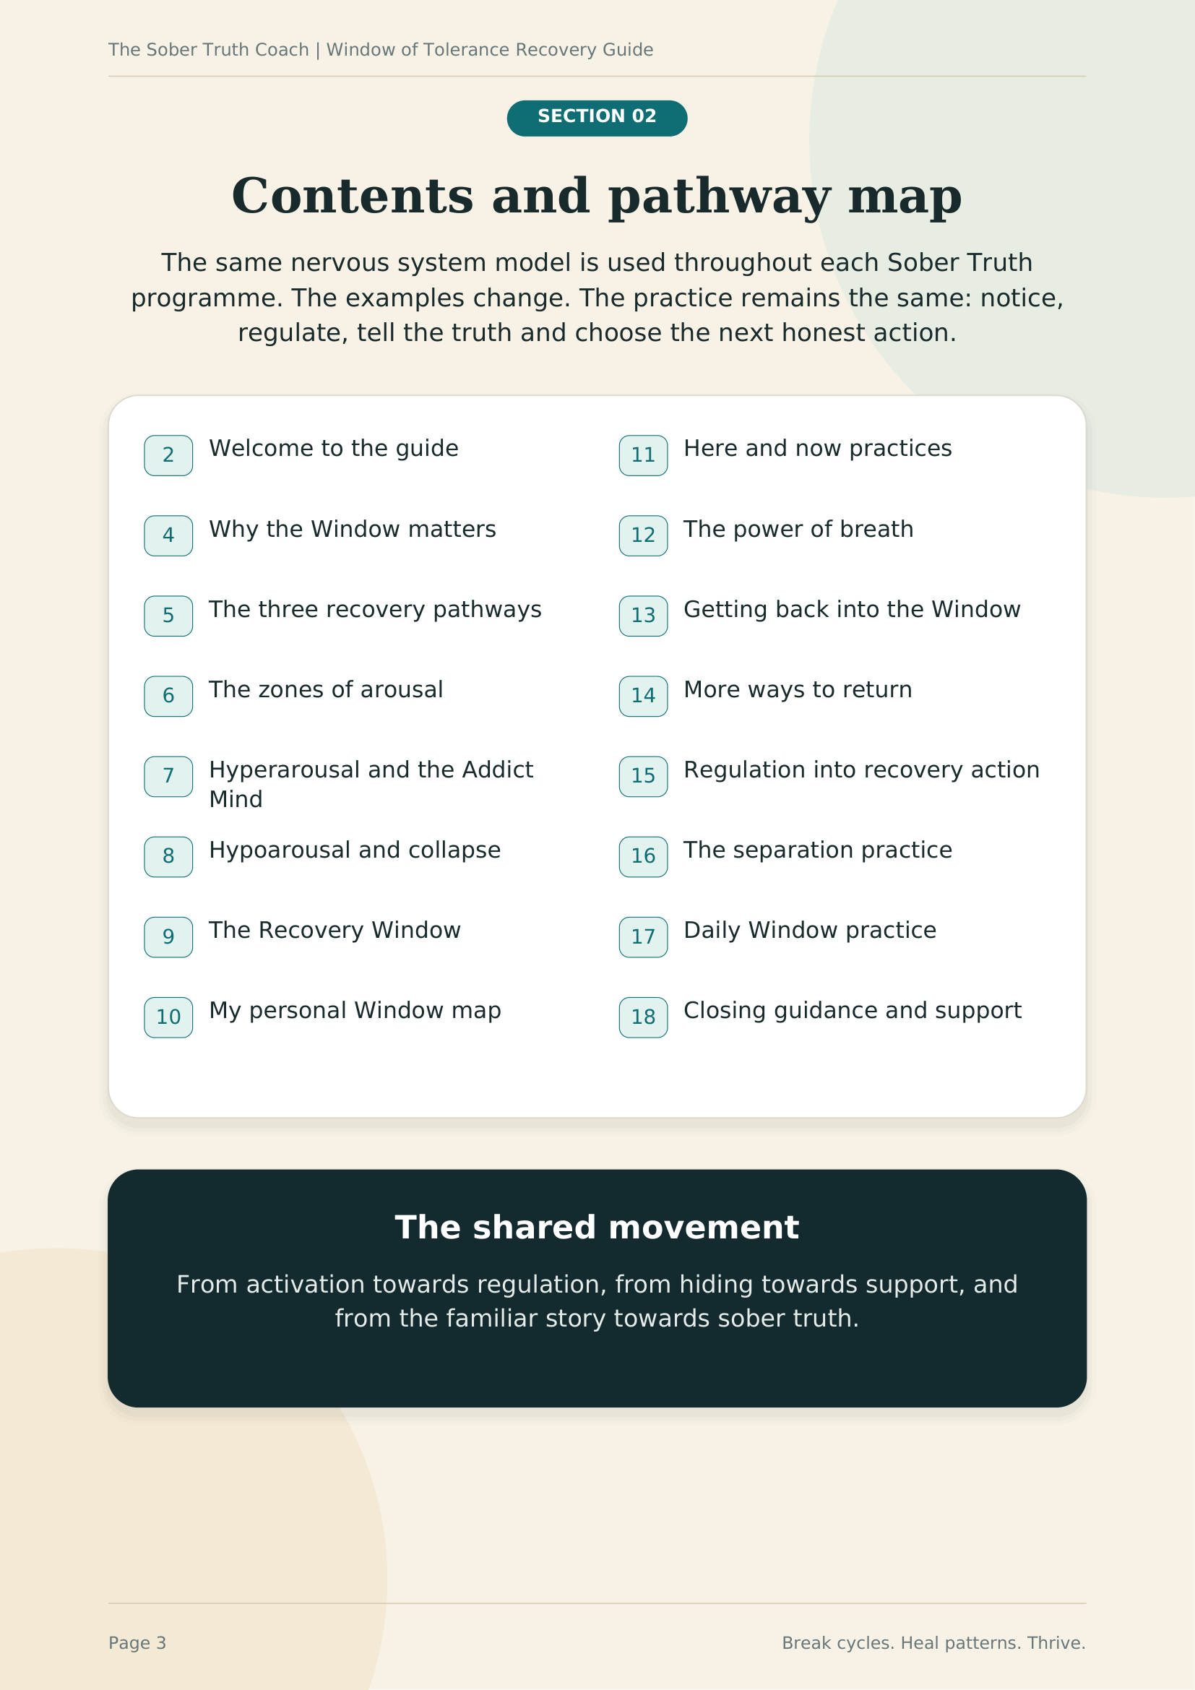

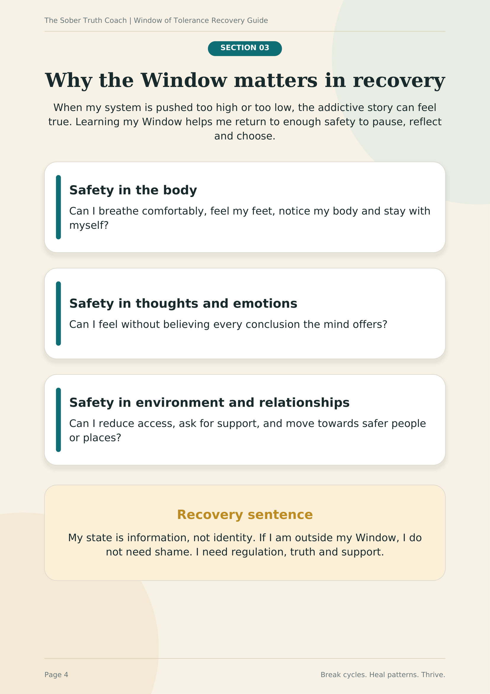

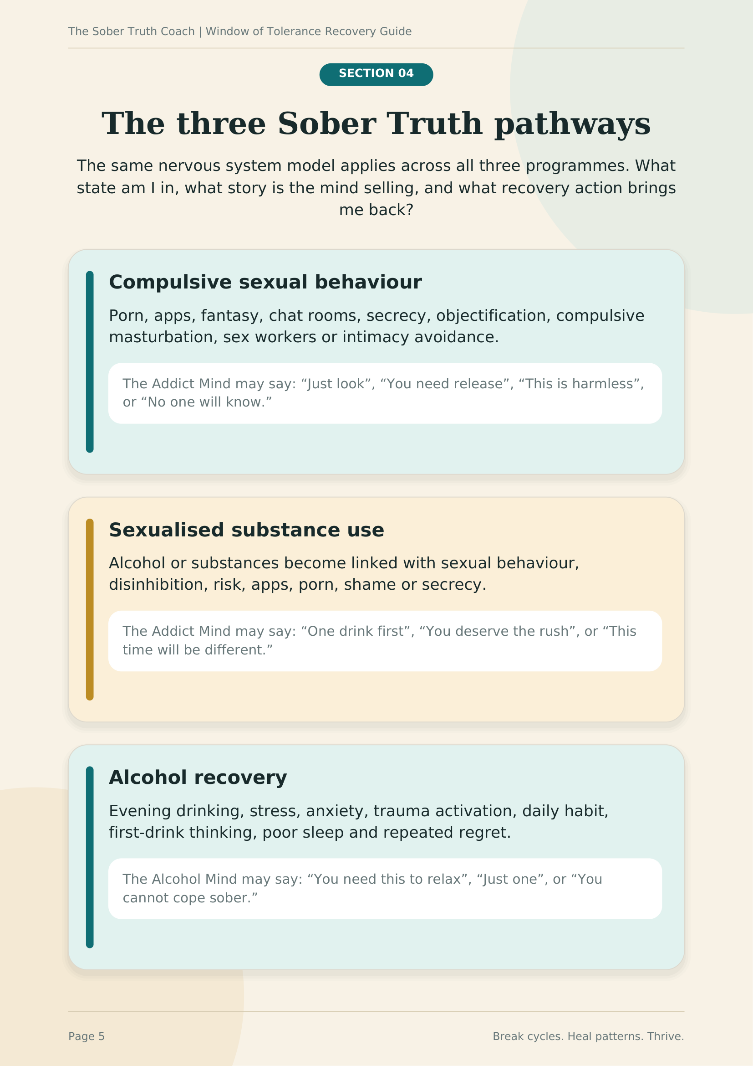

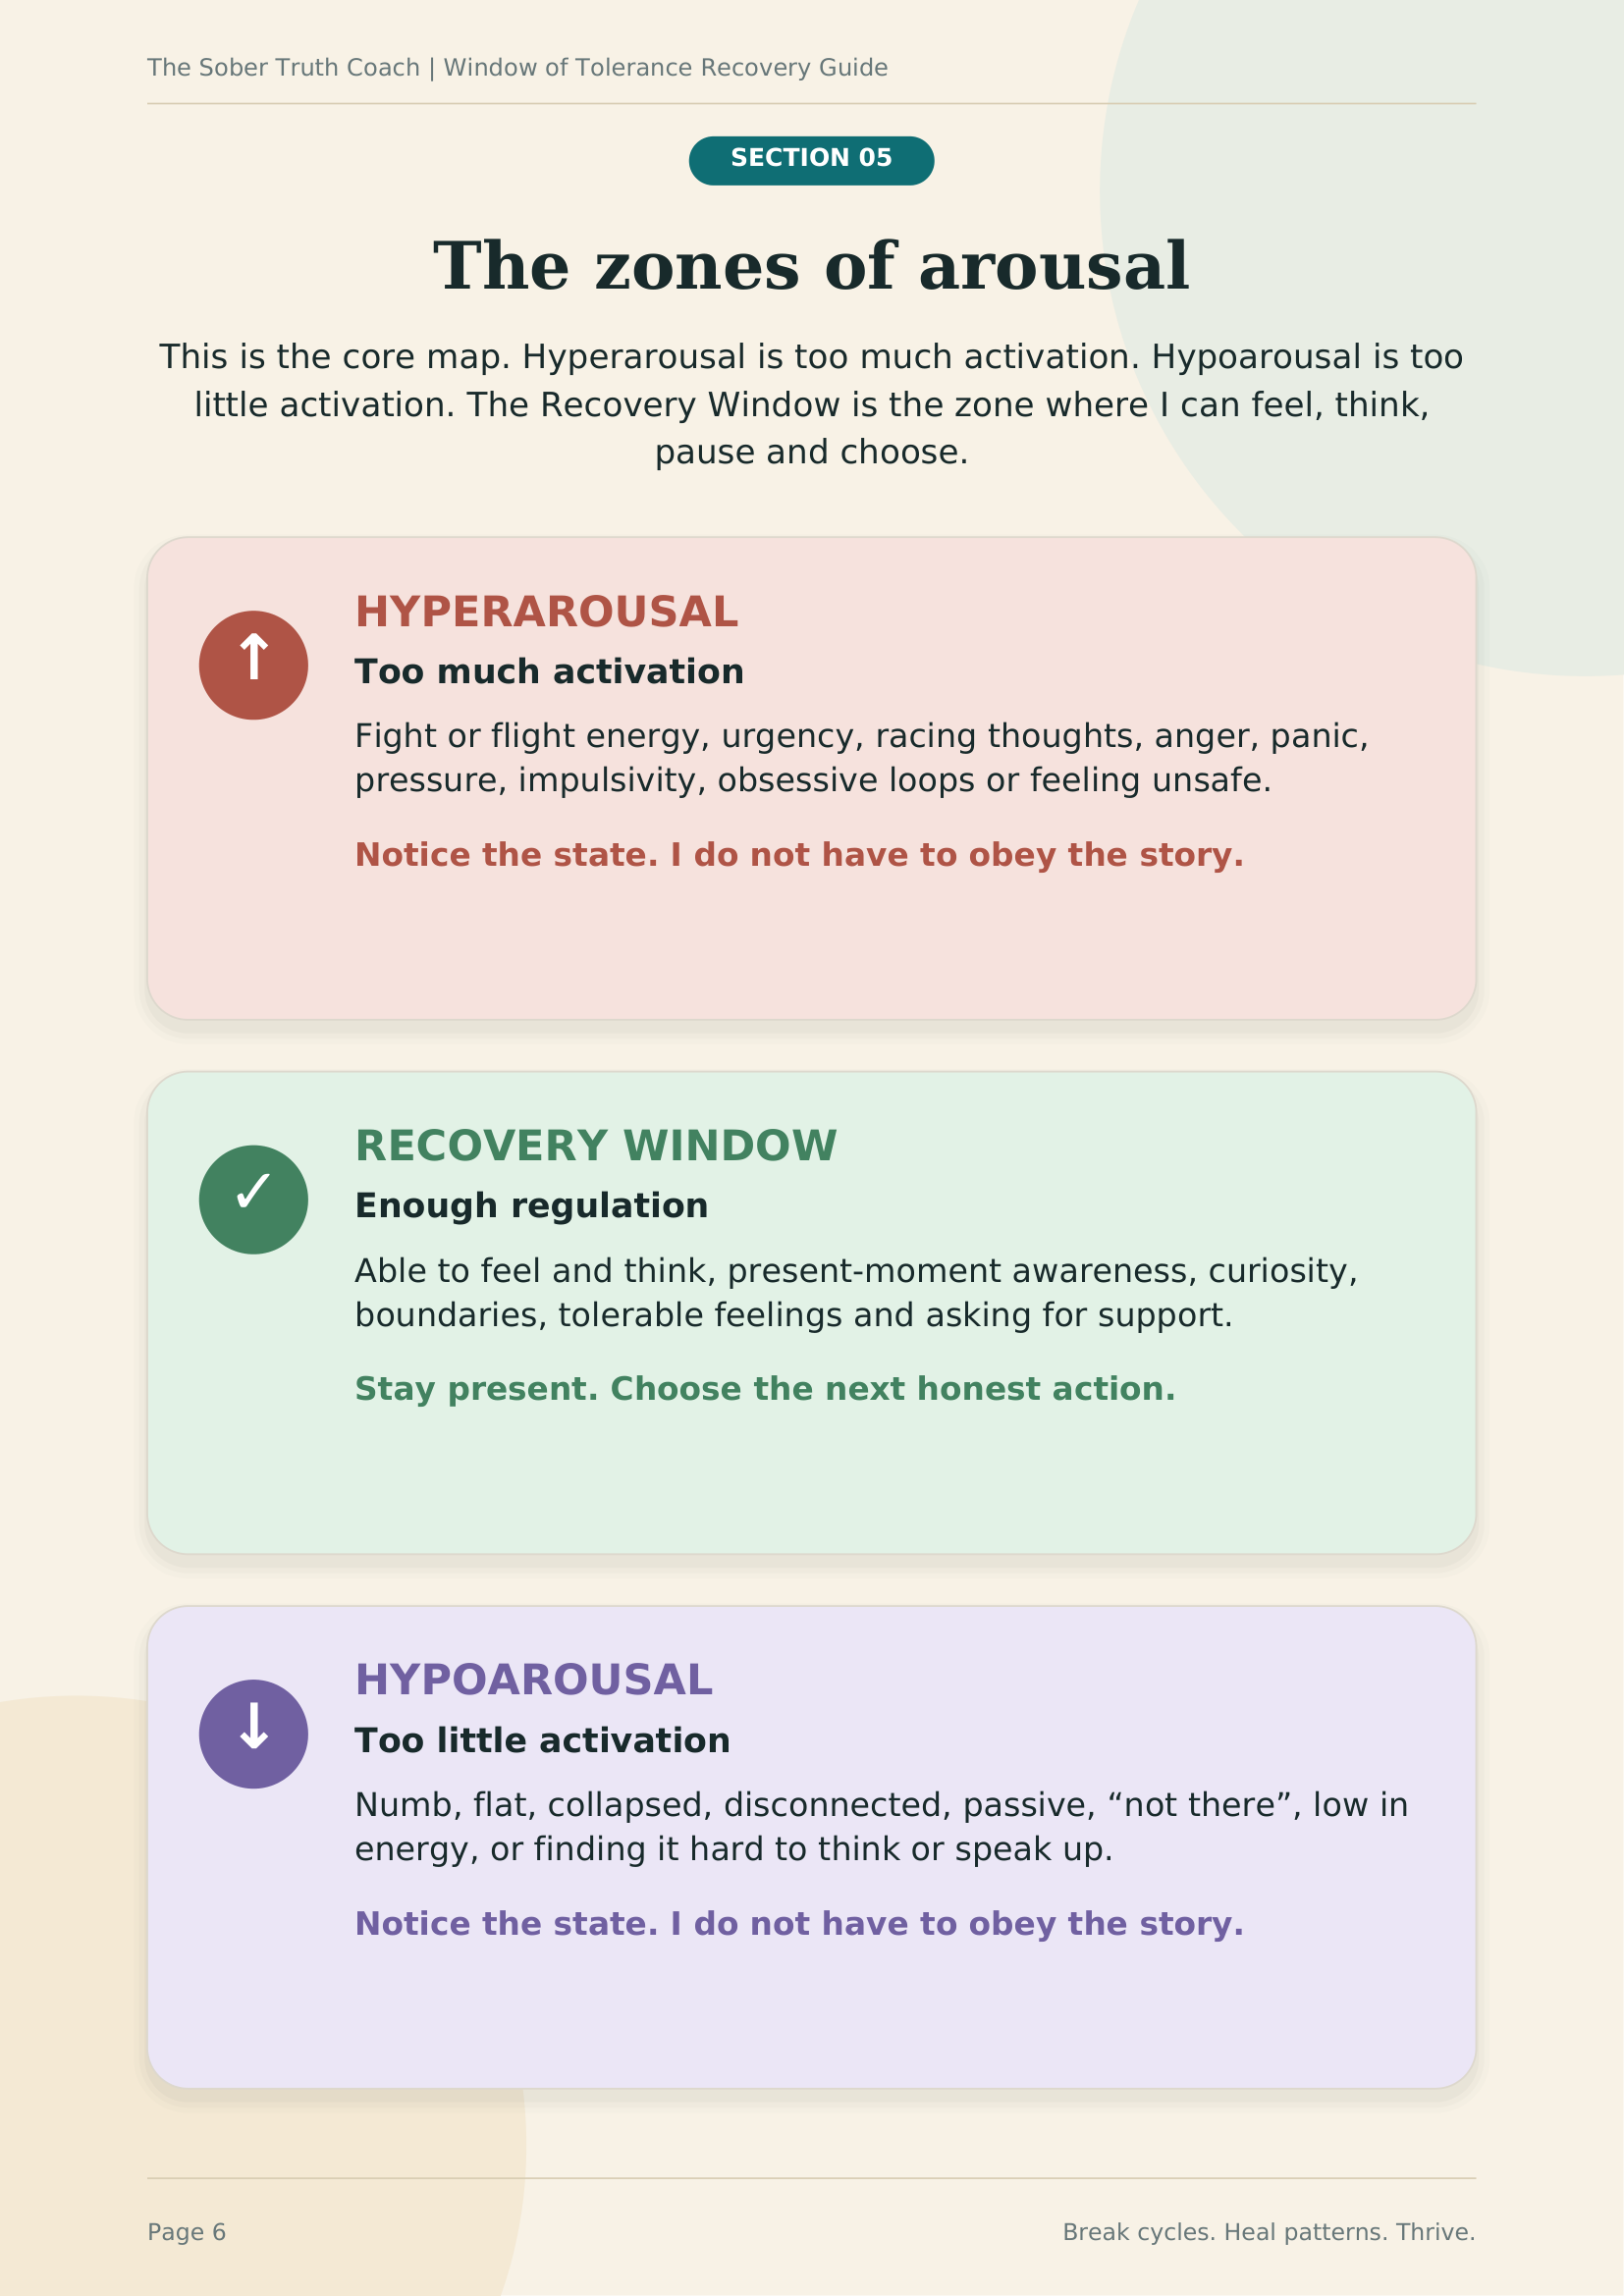

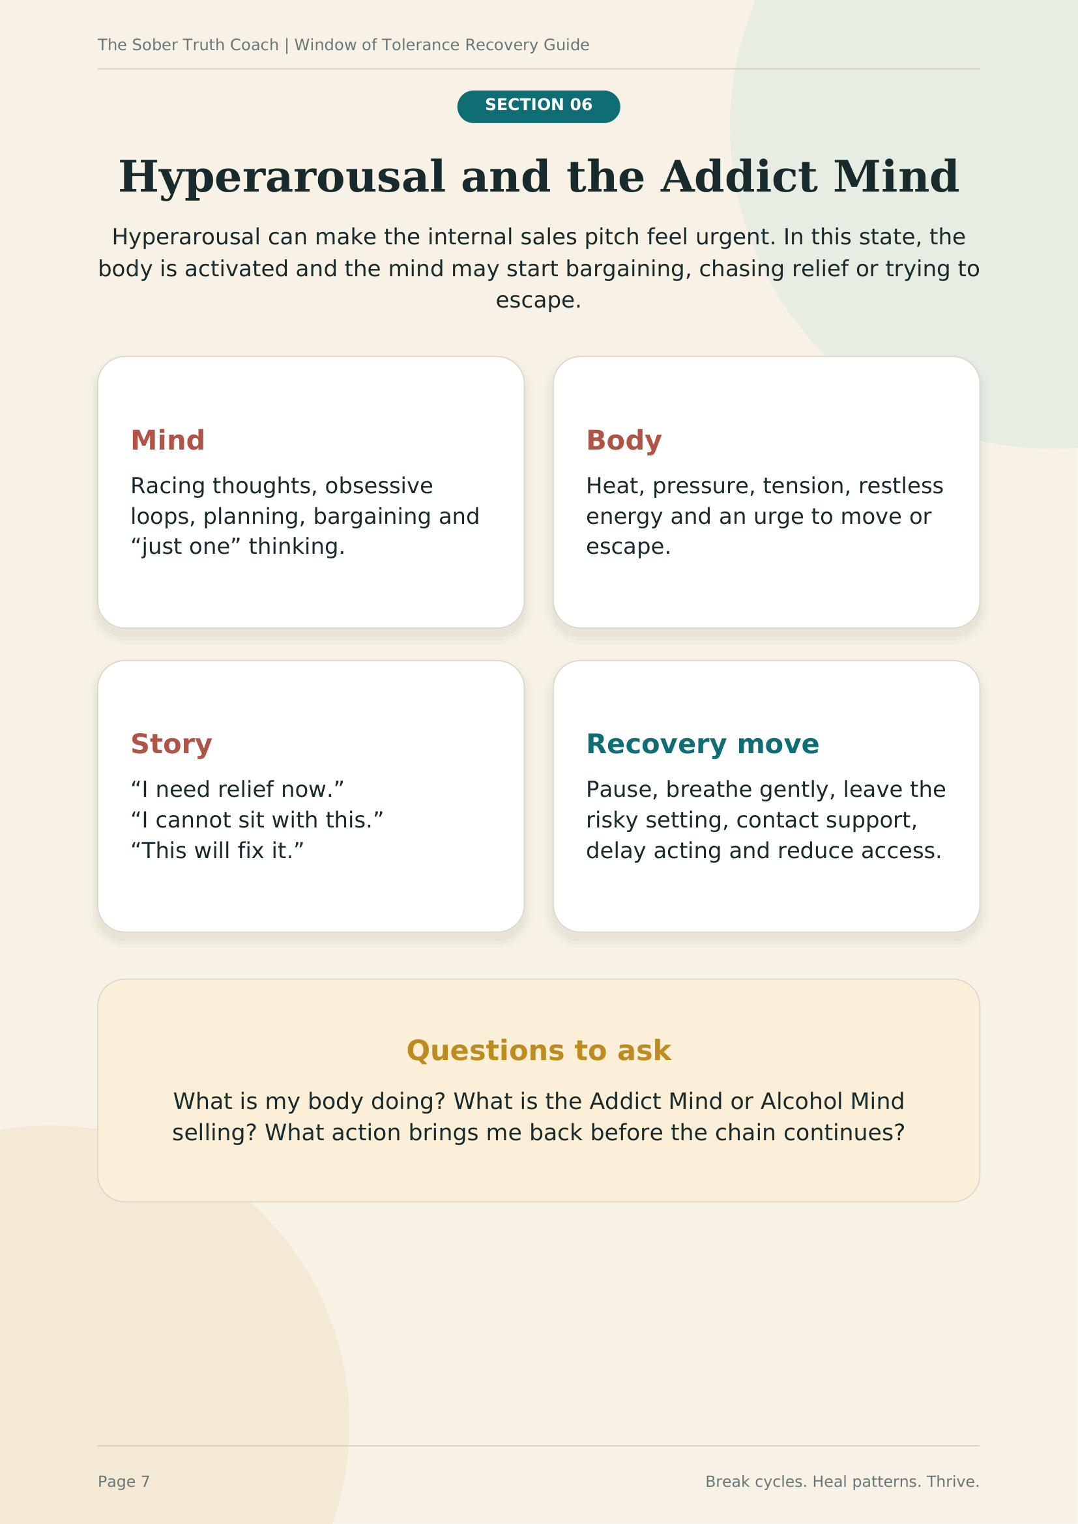

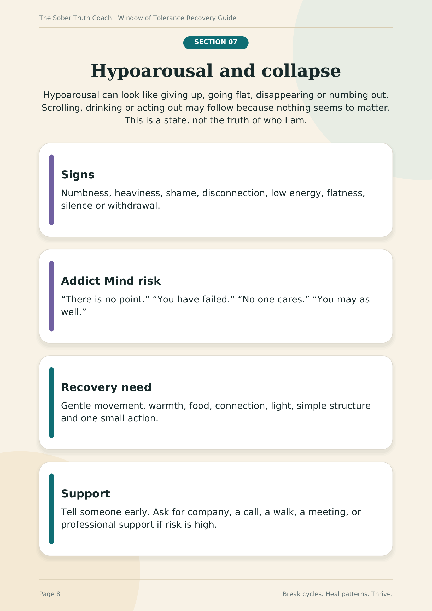

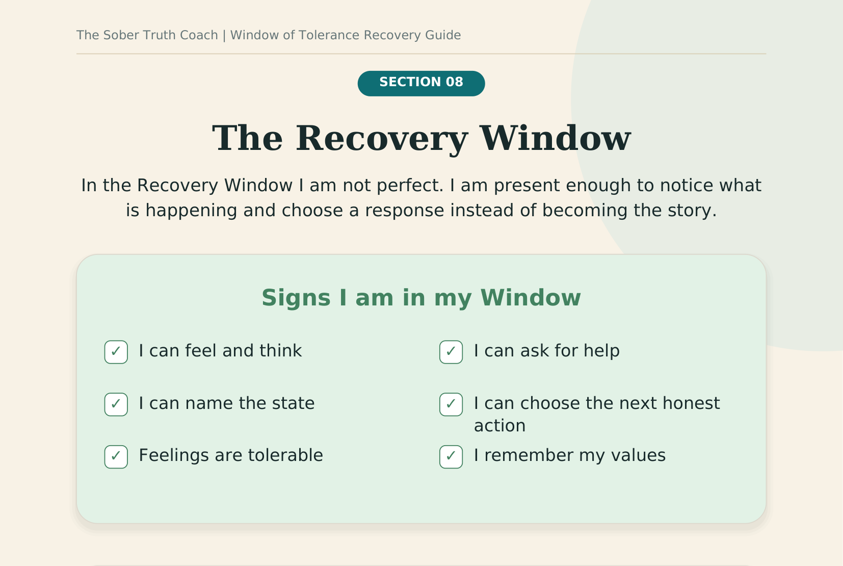
Reflection
What helps me feel safe in my body?
Type here
What helps me tell the truth earlier?
Type here
Who helps me return to recovery?
Type here

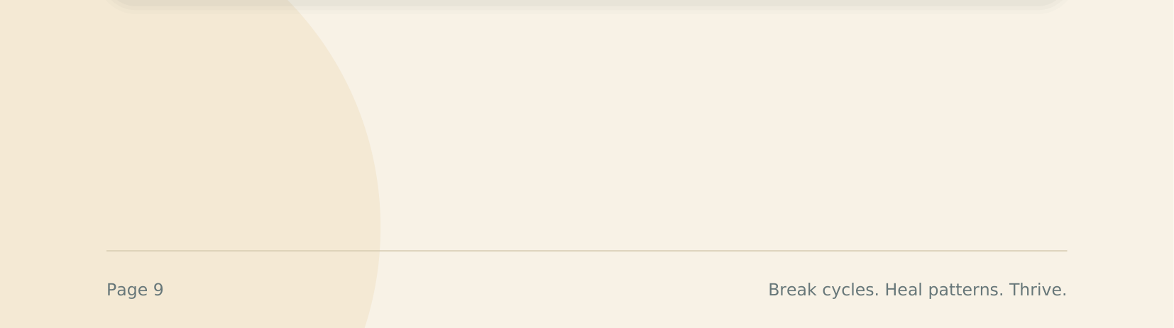

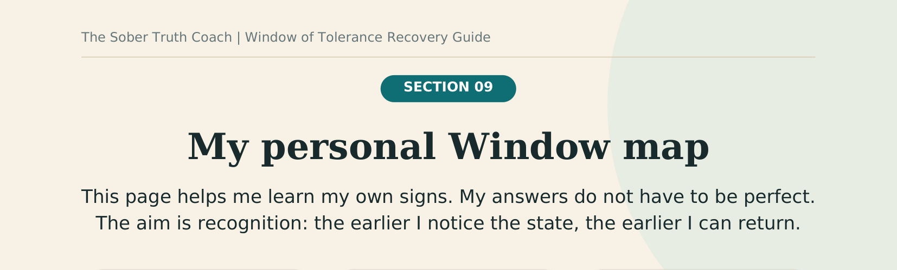
  HYPERAROUSAL
  My body
  Type here
  My thoughts
  Type here
  My emotion
  Type here
  My risk
  Type here
  RECOVERY WINDOW
  My body
  Type here
  My truth
  Type here
  My support
  Type here
  My next action
  Type here
  HYPOAROUSAL
  My body
  Type here
  My thoughts
  Type here
  My emotion
  Type here
  My risk
  Type here

Daily reflection
Today my nervous system state was
Type here
The story the mind offered was
Type here
The recovery action that helped was
Type here

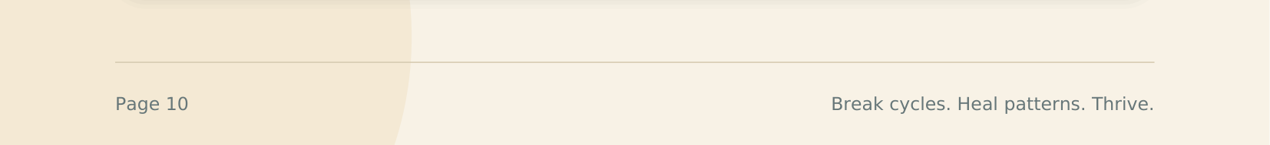

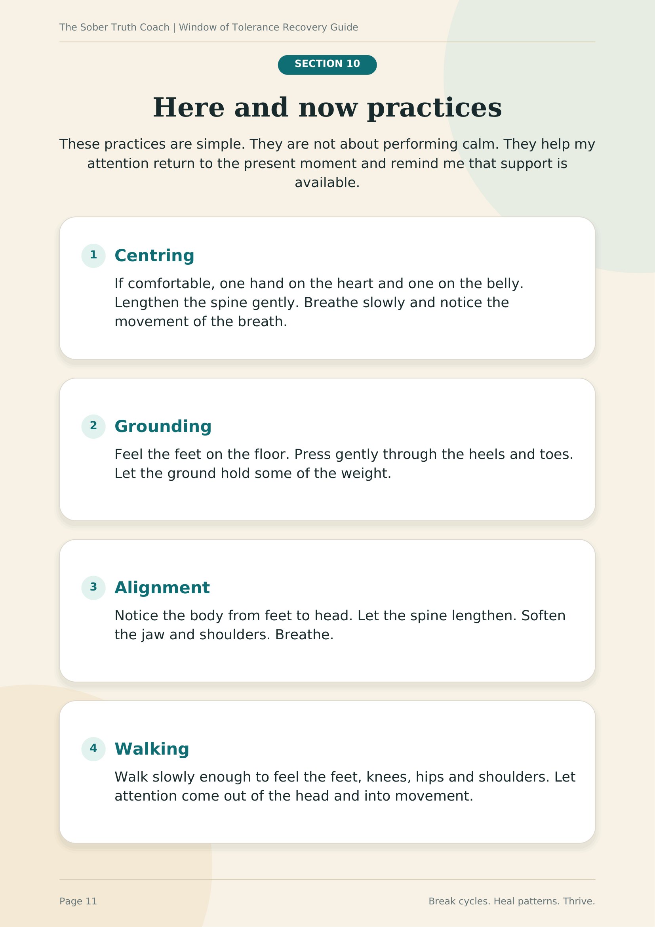

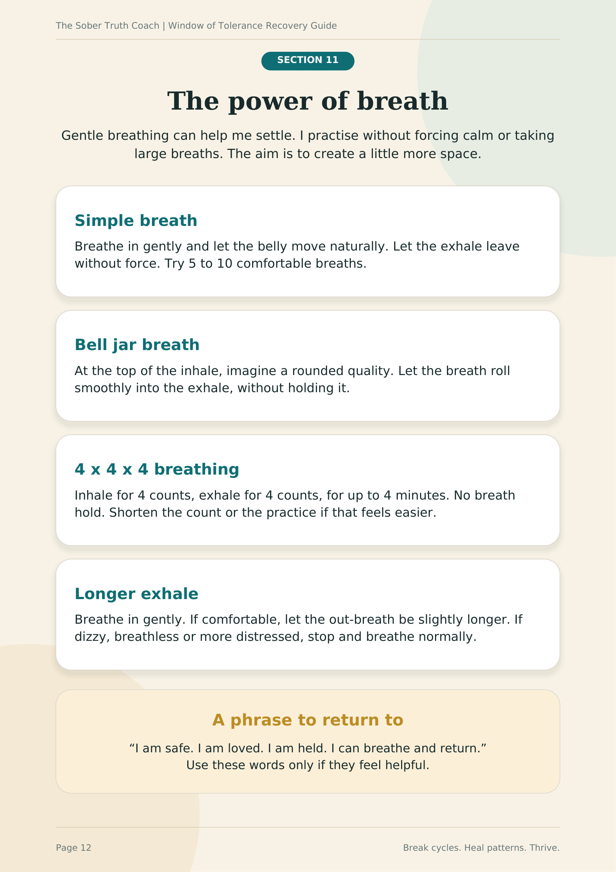

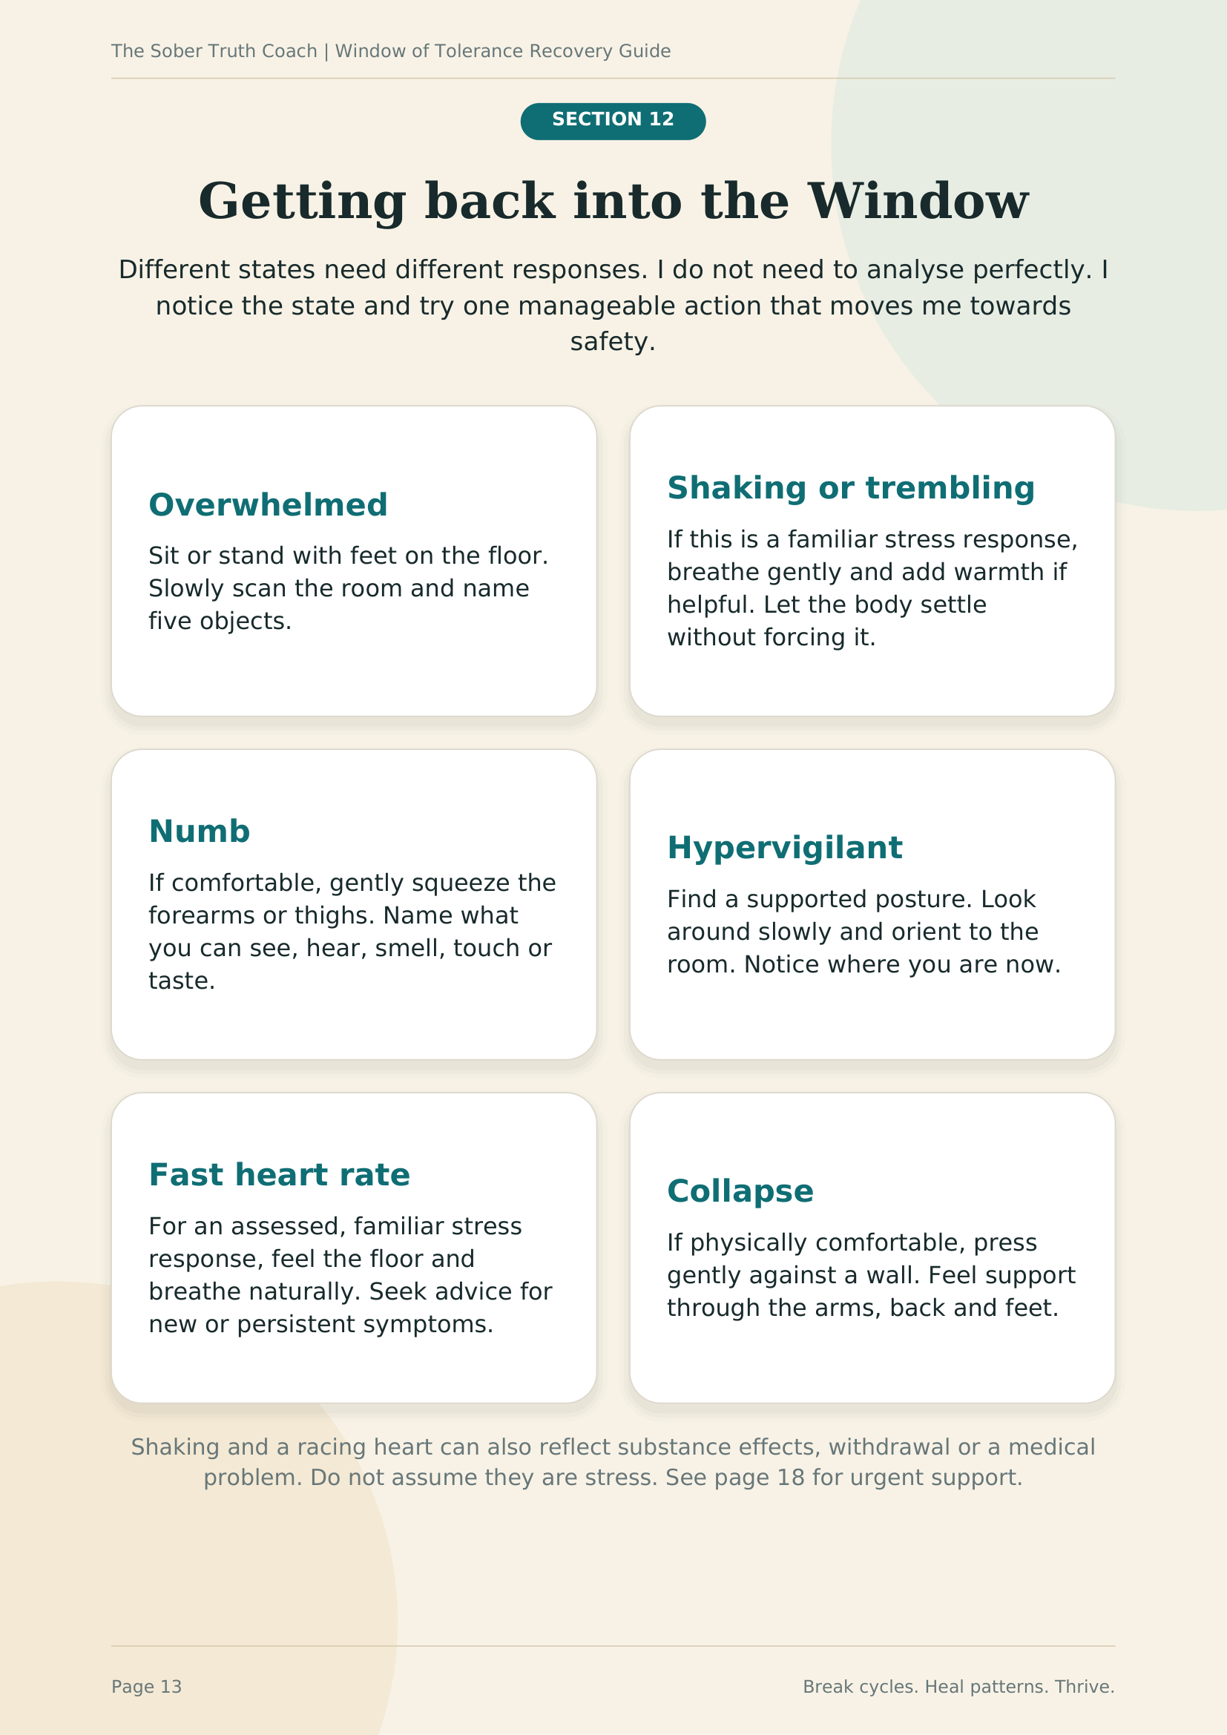

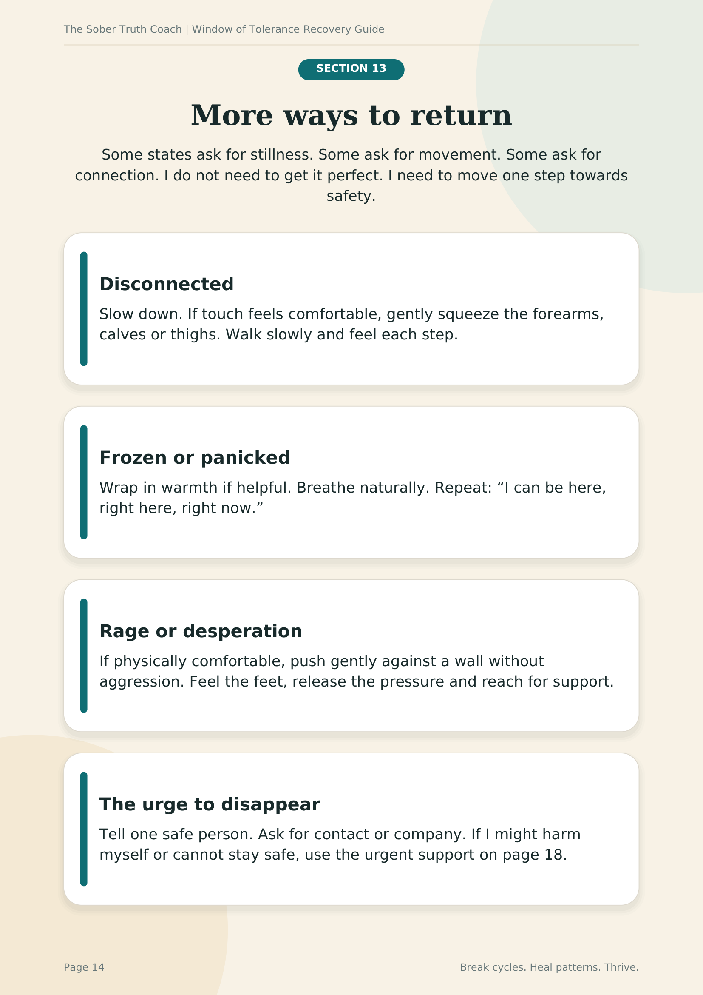

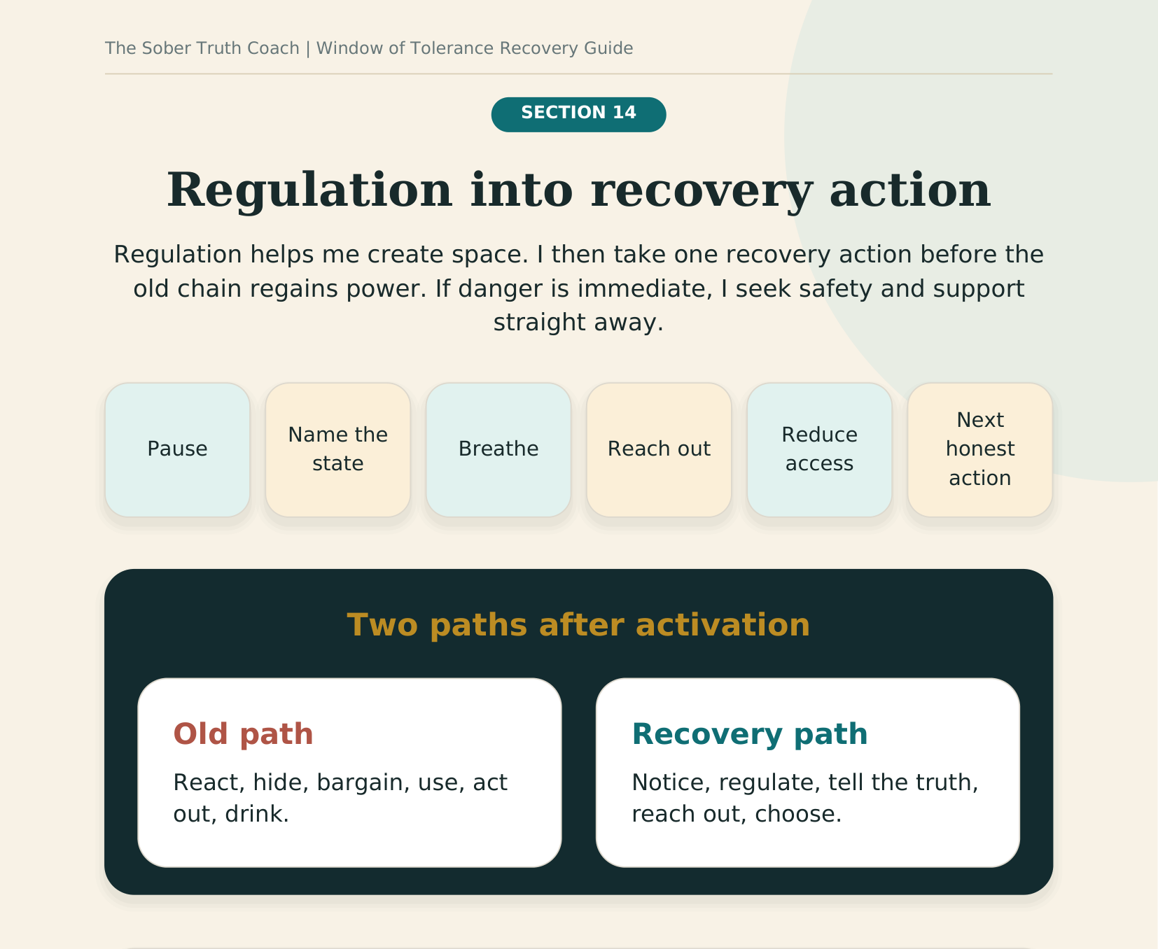
My next recovery action
My state is
Type here
The story is
Type here
The next honest action is
Type here

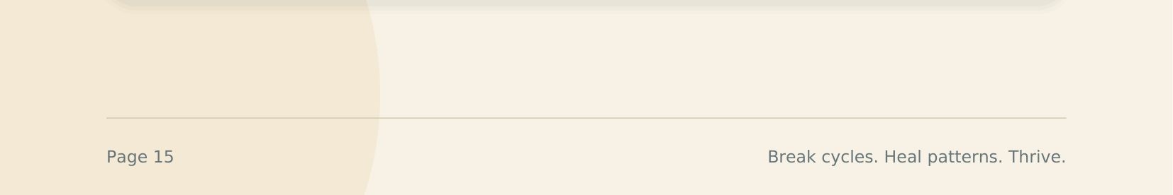

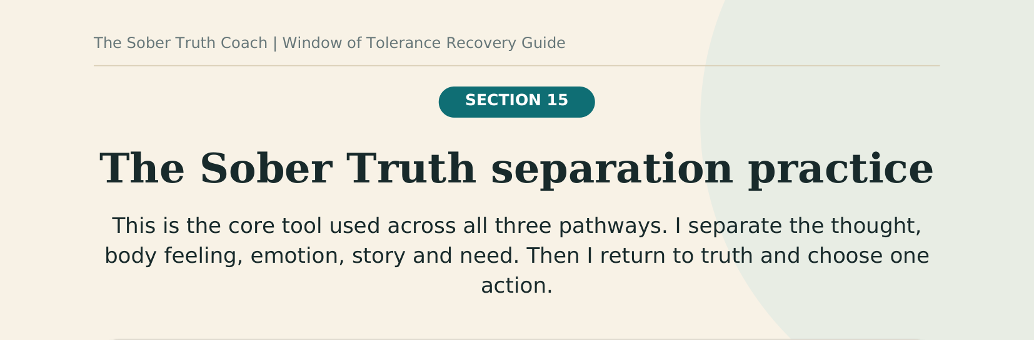
The Addict Mind or Alcohol Mind says
What is the lie, bargain or promise?
Type here

My body feels
Where do I feel activation, urgency, collapse or craving?
Type here

The emotion underneath may be
What am I feeling, or finding difficult to feel?
Type here

The real need is
What do I need: rest, support, safety, food, honesty or comfort?
Type here

My sober truth is
What does the grounded part of me know?
Type here

My next honest action is
What protects recovery now?
Type here

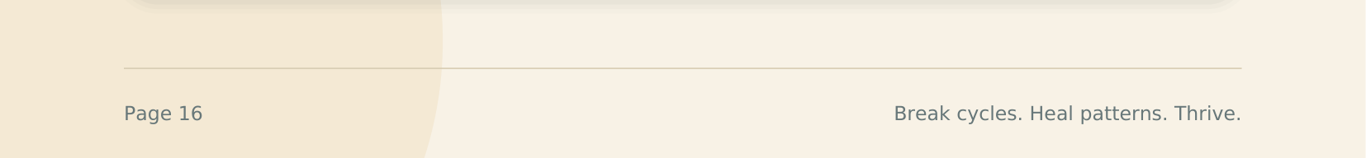

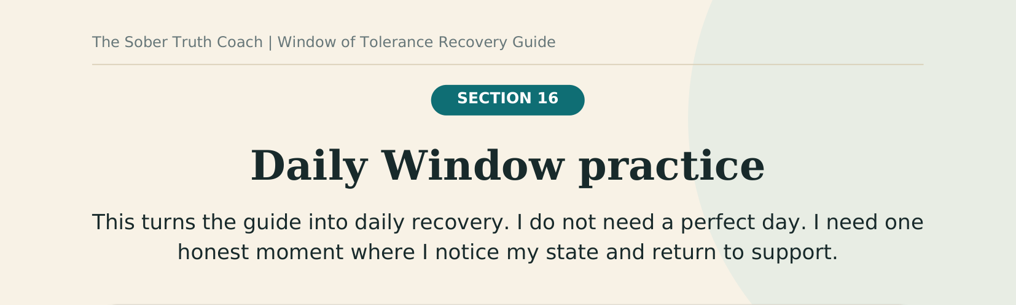

  Mon
  Type here
  Type here
  Type here
  Tue
  Type here
  Type here
  Type here
  Wed
  Type here
  Type here
  Type here
  Thu
  Type here
  Type here
  Type here
  Fri
  Type here
  Type here
  Type here
  Sat
  Type here
  Type here
  Type here
  Sun
  Type here
  Type here
  Type here

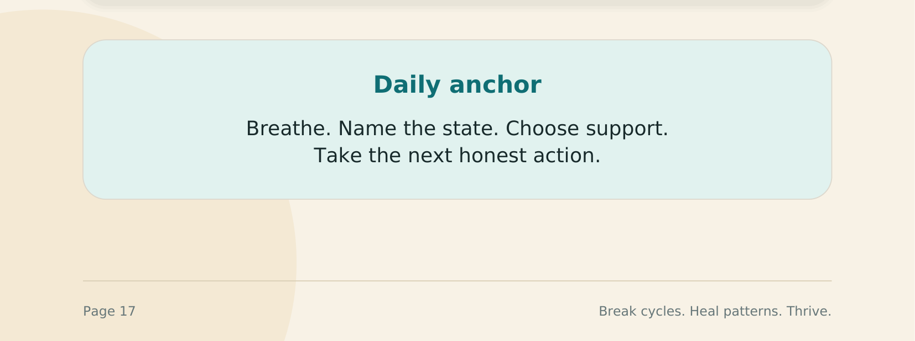

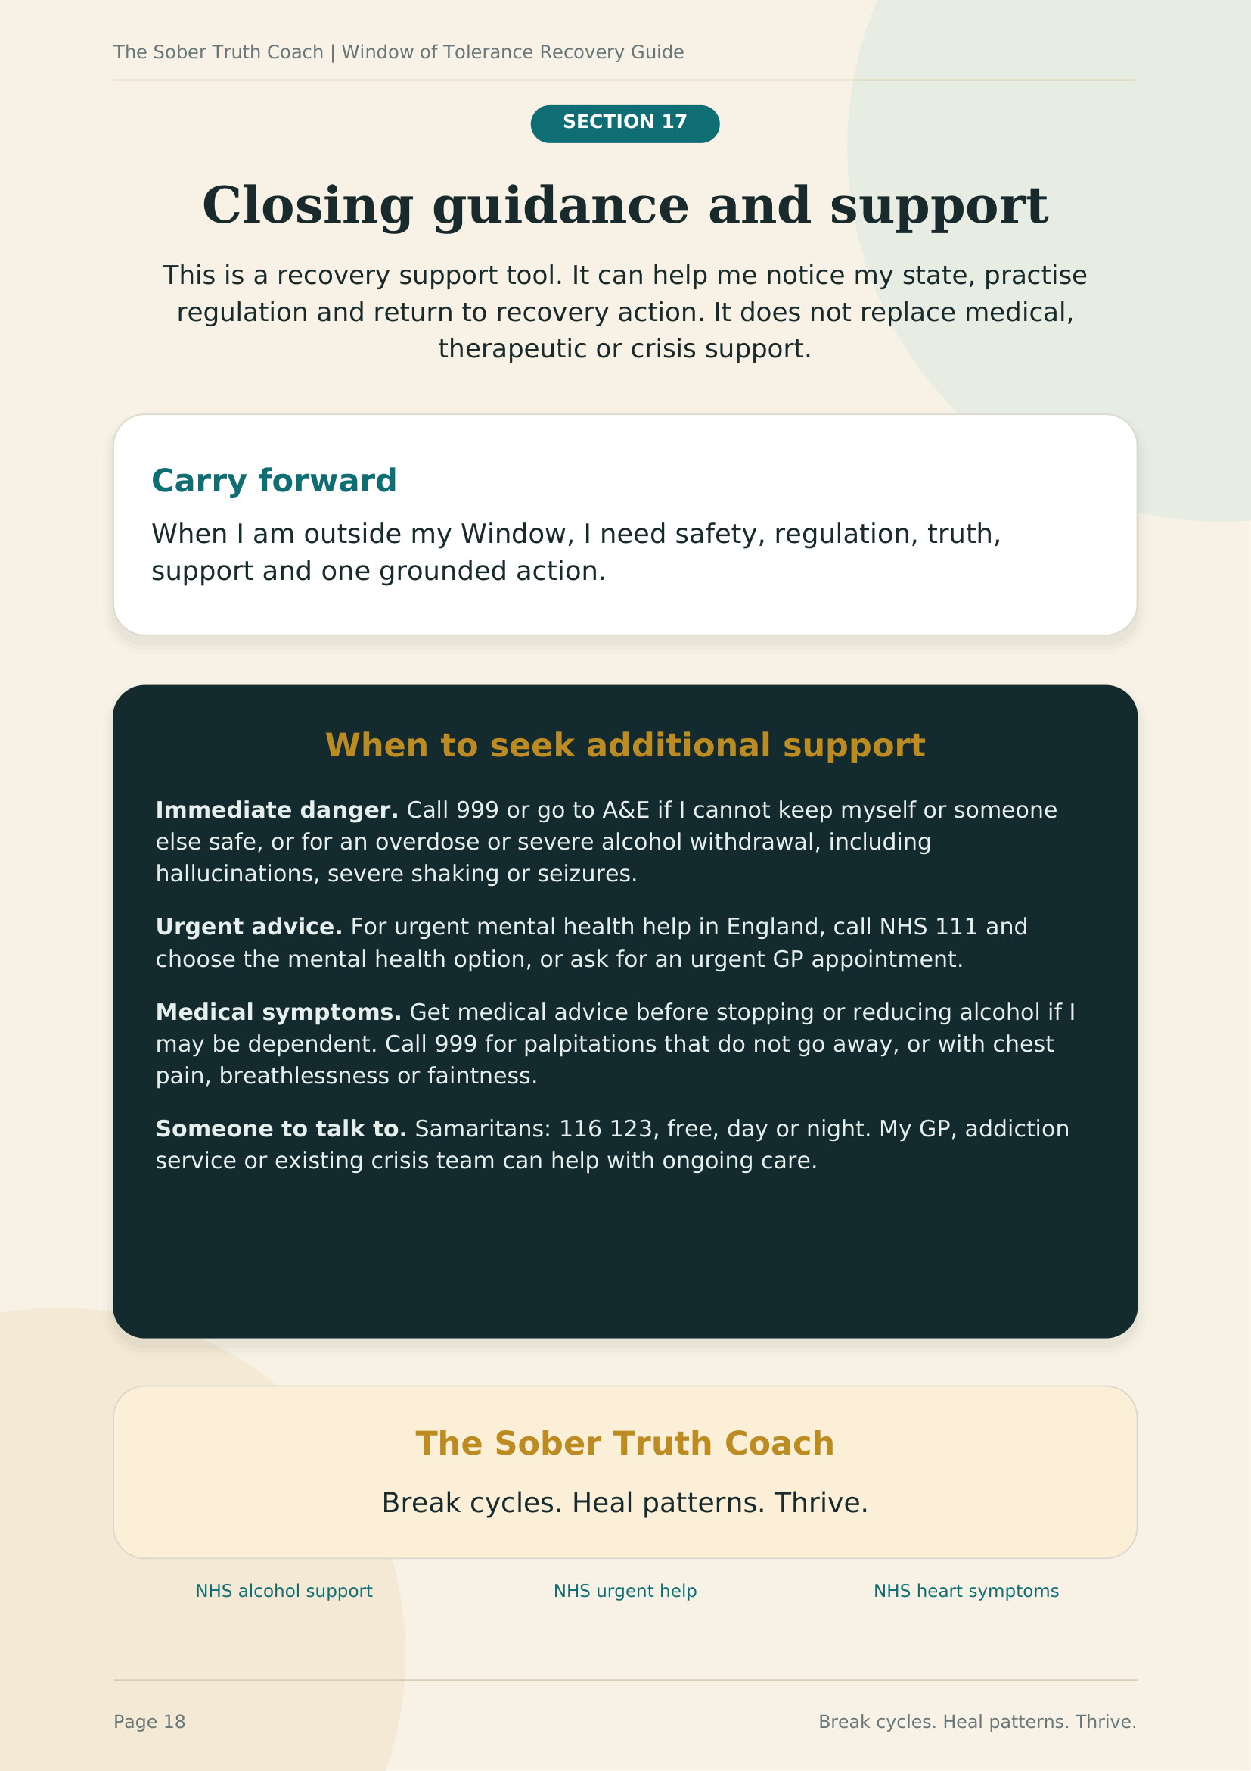

Book a free 30-minute clarity call

calendly.com/thesobertruthcoach/freeclaritycall

thesobertruthcoach.com

daniel@thesobertruthcoach.com

